Software Project Management Task

**Task 1:**

**Which tools would you use in Jira and any add ons to report on each division to give the senior stakeholders instant productivity reports?**

### Answer 1:

### Tools:

1. Zephyr
2. eazyBI

### Add-ons:

1. BigPicture by SoftwarePlant company

#### Zephyr

* Better traceability with the linkage between stories, test cases and bugs in the test cycles.
* Graphical representation of the results
* Test cases can be exported to word, excel formats.
* Test case review process possible through agile board.
* Multiple test iterations with multiple cycles can be created.
* Possible to create customized filters

#### eazyBI

* Import dozens of agile, sprint, project, version, time tracking, cycle time, forecast, issue overview, or SLA reports and dashboards in seconds with ZERO coding.
* Explore with instant results, filter, order, drill-across dimensions or into hierarchy details, discover trends, outliers, opportunities, or threats.
* One-click standard calculations: statistical, trends, cumulative, and more.
* MDX editor with syntax highlighting and auto-complete for advanced custom calculations.
* Integrations with popular apps: Bamboo, Bitbucket, Insight, Tempo, Profields, Zephyr, Xray and more.
* Analyze external databases and files: SQL, REST, CSV, Spreadsheets.
* Measure anything–standard or custom fields.

#### BigPicture

* The BigPicture suite contains the Gantt chart module which can be used to create and organize tasks with sorting and grouping.
* Tasks can be managed through a drag & drop function.
* Easily build roadmaps and help the team gain a common understanding.
* Import and Export from/to Excel and MS Project.
* Project managers are often concerned about the risks like resources run out, hardware breaks etc. BigPicture offers easy risk identification and management using drag and drop.
* Resources are usually a concern for most project managers. Enhanced task allocation feature in BigPicture allows quick and easy task assignments through its Resource view.
* Mark and color tasks.
* Quick inline editing of issues.

### Reports shared with senior stakeholders

#### Average age report

The Average Age Report is a bar chart that shows the average amount of time in hours, days, months, or years for which issues have remained unresolved. The report also tracks current efforts toward issue solution. Reviewing the Average Age Report indicates whether the project is on track for deployment

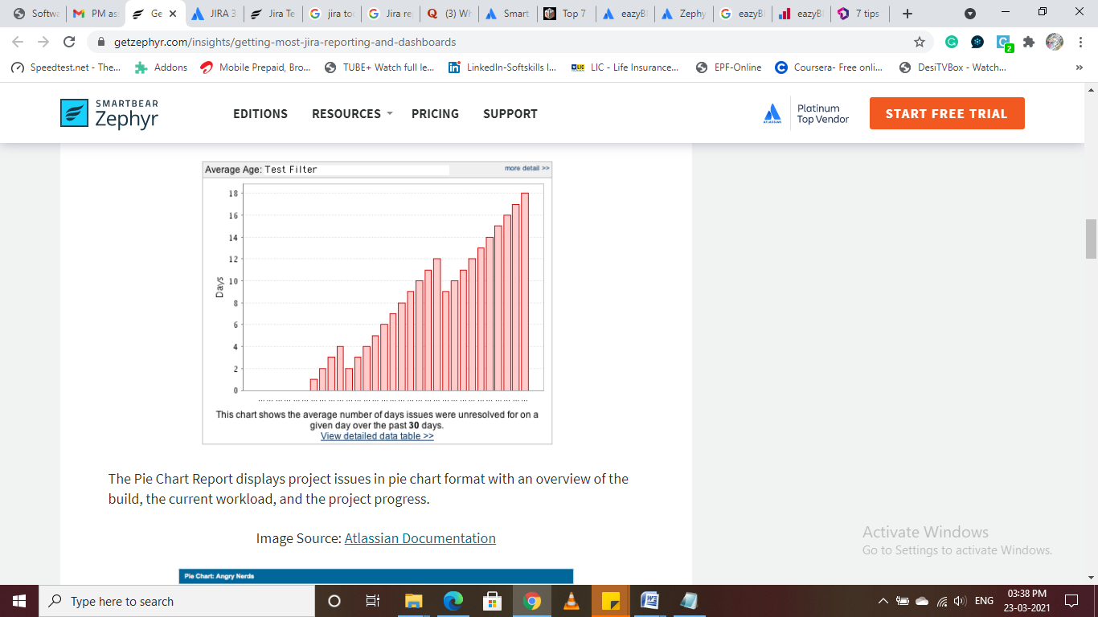

#### Pie Chart:

The Pie Chart Report displays project issues in pie chart format with an overview of the build, the current workload, and the project progress

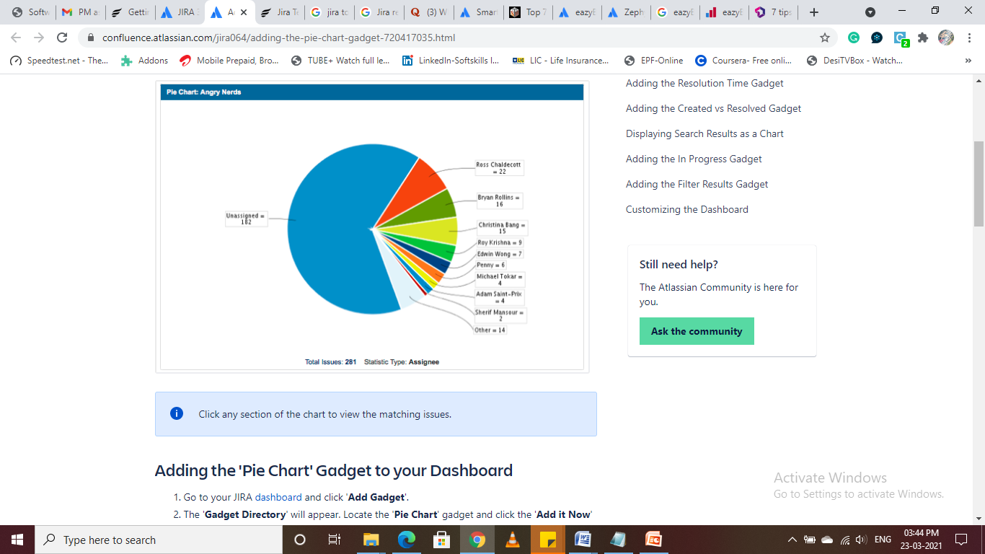

#### Heat Map:

The Heat Map includes a pie chart, and displays the queried values of a project issue. Issues are filtered by personalized labels that denote the issue details. Heat maps also assist in balancing the distribution of responsibilities among team members.

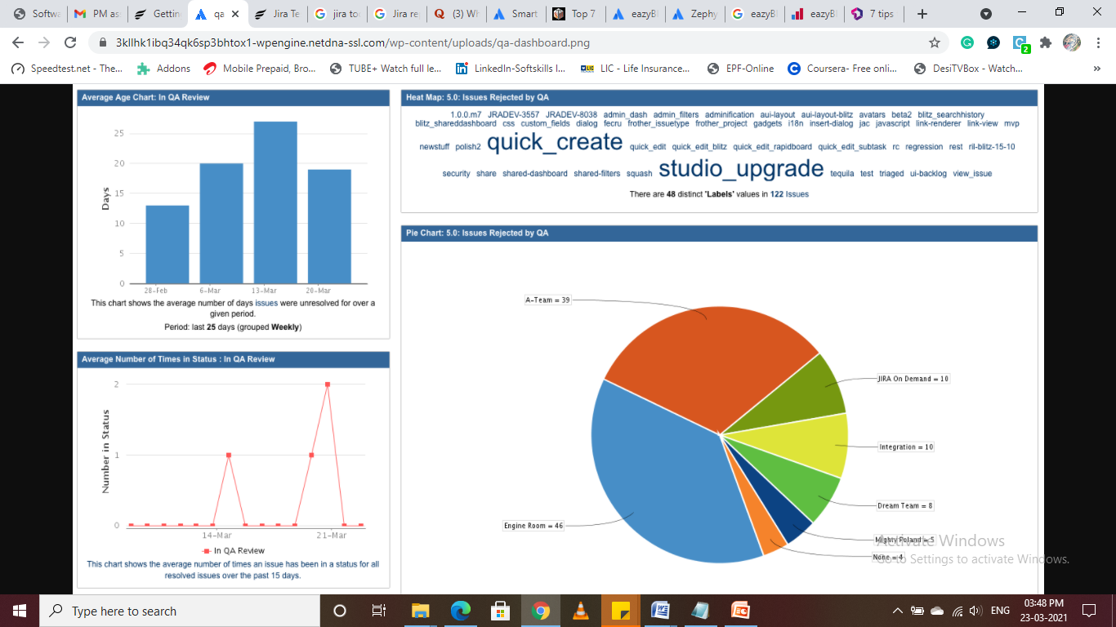

#### Sprint Health gadget

The Sprint Health gadget track progress for different projects and teams, as shown below:

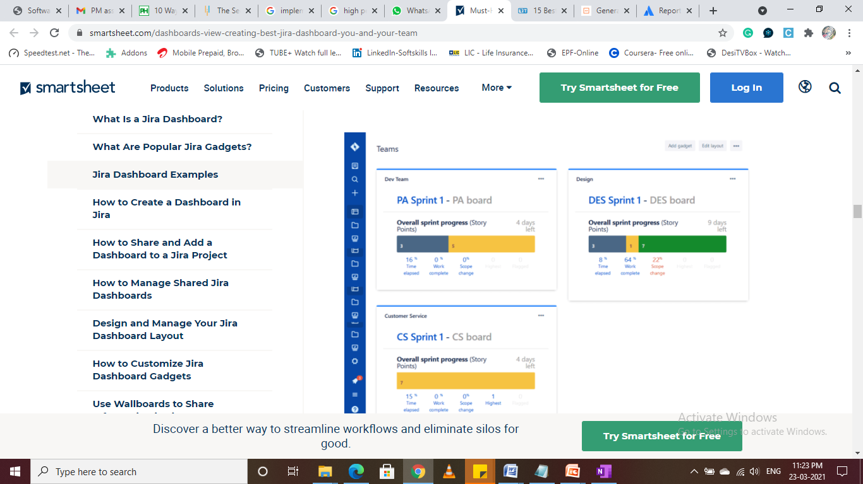

**Task 2:**

**How and what data would you be looking at to see if a team/individual is producing their set target deliverables?**

### Answer 2:

To see if a team or individual is producing their set target deliverables we can use:

* 1. Advanced Roadmaps in Jira
  2. Project Tracking software from Projectmanager.com

### Advanced Roadmaps - Jira:

When we connect a plan with our boards and projects, Advanced Roadmaps can detect the estimation unit of these issues, with the following conditions to note:

1. If issues are estimated in hours or days, **time-based progress tracking** will be used.
2. If issues are estimated in story points, **point-based aggregation** will be used.
3. If we connect to boards and projects that have different plan units, we can select which **estimation unit to use**.
4. If we leave issues un-estimated, **progress will be calculated based on issue completion, as well as the progress of child issues**, if any.

Once our plan is created, a progress bar is displayed for individual issues. Parent issues will display an aggregated progress bar, corresponding to the individual progress of all the child issues. We can also check the progress of releases in the release view

#### The progress tracking bar

The progress status bar shows the un-estimated issues in relation to items that are estimated. This allows us to see the percentage of work done on estimated items as well as the issues that are still outstanding and require work.

* Issue status: The actual workflow status of these issues
* Progress: Sum of logged work on the linked Jira issues, as well as child issues, if any
* When a parent issue is expanded, the bar shows the total progress of all the child issues.
* Items with no progress are displayed as a faded grey line.
* Issues that are in progress show the completion percentage as a green line.
* Completed issues show a full green line.
* If an uncompleted child issue is part of a completed parent, Advanced Roadmaps will display a warning, indicating that the parent issue is already done — and therefore, the parent progress calculation won't take the children into account.
* **Time based progress tracking**

Time progress is measured by time logged on tickets and remaining estimates. When an issue is transitioned to the done status category in Jira, it will be shown as complete (100% progress) in Advanced Roadmaps.

When work time is logged for an issue, its progress is calculated as follows:

**Progress = Time spent / Time spent + Remaining estimate**

If no remaining effort is set, the original estimate is considered, and the progress is aggregated up the hierarchy.

* **Story point progress tracking**

Story point progress is calculated from the estimates set in Jira issues. Advanced Roadmaps considers an issue "Completed" when it is assigned to any status of the "Done" category, i.e. the green category. The progress of an epic is computed as:

**Progress = ∑ [estimate (story 1) x progress (story 1)...estimate (story n) x progress (story n)] / estimate (epic)**

If the issues are not estimated, progress is calculated based on the issue’s status category change date and the progress of child issues.

**Calculating progress for issues with child issues**

If an issue has child issues, progress is calculated as follows: **Progress = Number of child issues in the done status category / Total number of child issues**

**Calculating progress for issues without child issues**

If an issue doesn’t have child issues, and the issue is in the done status category, the progress is 100%. Otherwise, the progress is 0%.

* **Issues without estimation**

The following fallback is used if your issues have no estimation. Progress is calculated based on the issue’s status category change date and the progress of child issues.

**Calculating progress for issues with estimates**

If an issue has estimates, progress is calculated as follows: **Progress = Number of child issues in the done status category / Total number of child issues**

**Calculating progress for issues without estimates**

If an issue doesn’t have estimates, and the issue is in the done status category, the progress is 100%. Otherwise, the progress is 0%.

### Project Tracking software from Projectmanager.com

Project Tracking Software is of the best way to keep track of projects because it monitors all the tasks associated with our project and helps to stay on schedule. Most project tracker software is not used only for tasks; it can also keep track of your budget and resource management

**Project Tracking and Reporting in ProjectManager.com**

#### Gantt Charts

Using the Gantt Charts, team members can get an overview of project progress. We can see team’s progress by looking at the duration bar that connects the start to the end date of each task. The more shaded in it is, the closer it is to completion. Gantts also have a milestone feature to break the project into smaller stages, which also helps track the larger movement of the project. These interactive features make ProjectManager.com’s Gantt charts a much better choice than plain Gantt chart templates when it comes to task and time tracking

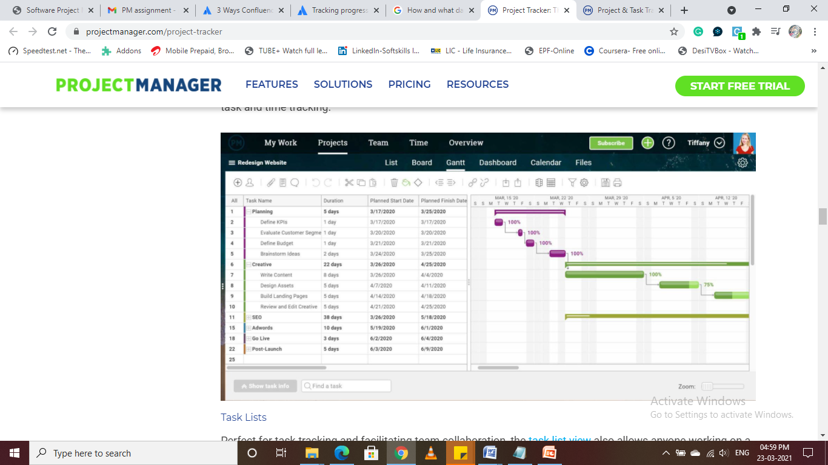

#### Task Lists

The task list views allow anyone working on a project to filter tasks down to just those for which they are responsible. Task lists show who is assigned to the task, the priority, due date, progress and more. There is a deeper tier of data that can be seen, such as logged hours, and tasks can be sorted and filtered to quickly find the task you’re interested in.

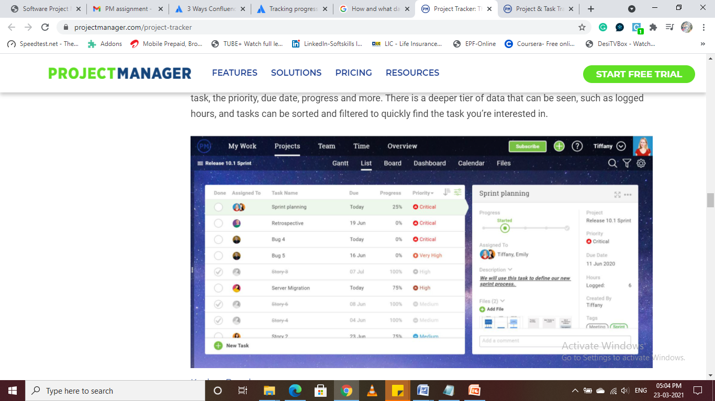

#### Kanban Board

Kanban boards allow teams to organize their product backlog and get transparency into the process so we can reallocate resources as needed to avoid bottlenecks or blocking team members.

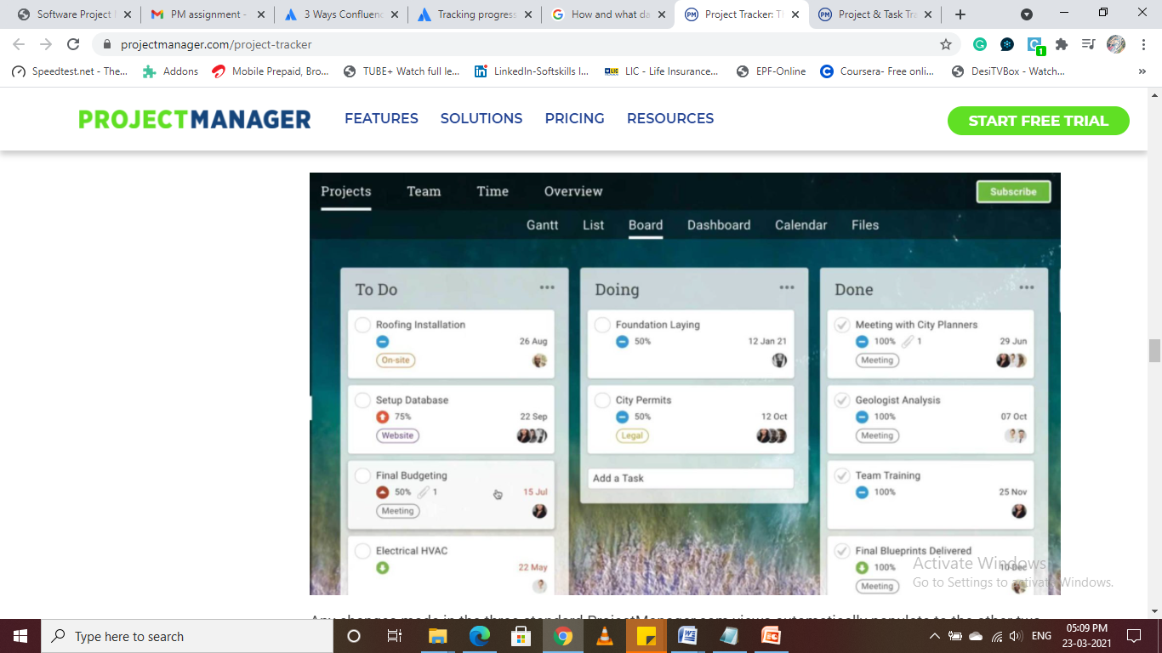

#### Real Time Dashboard

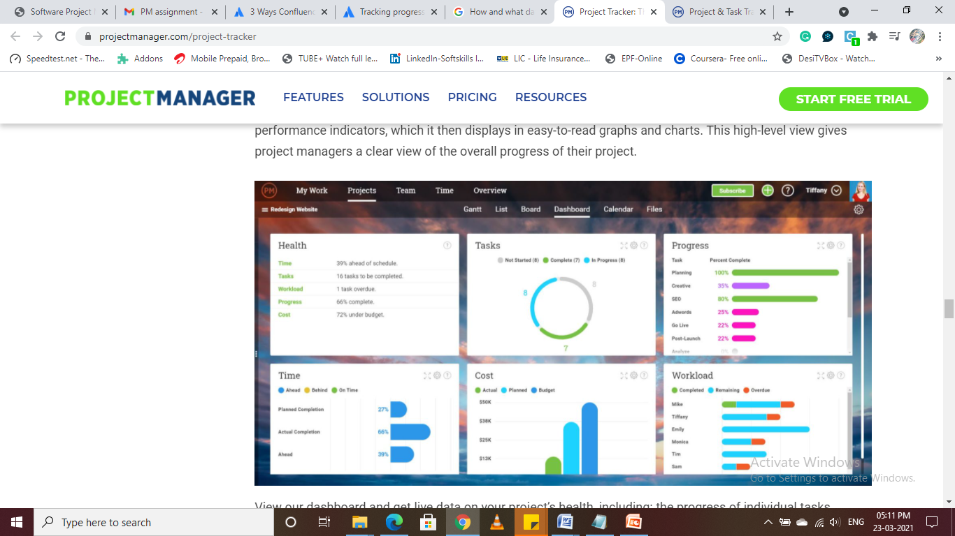

#### Tasks Report

### 

#### Track Big Steps with Milestones

Placing milestones on our Gantt chart with a single click, they are represented by a diamond-shaped symbol. Now, we can track critical deadlines and the passage from one stage to the next—and see how the project is tracking against the milestones set during the project planning phase.

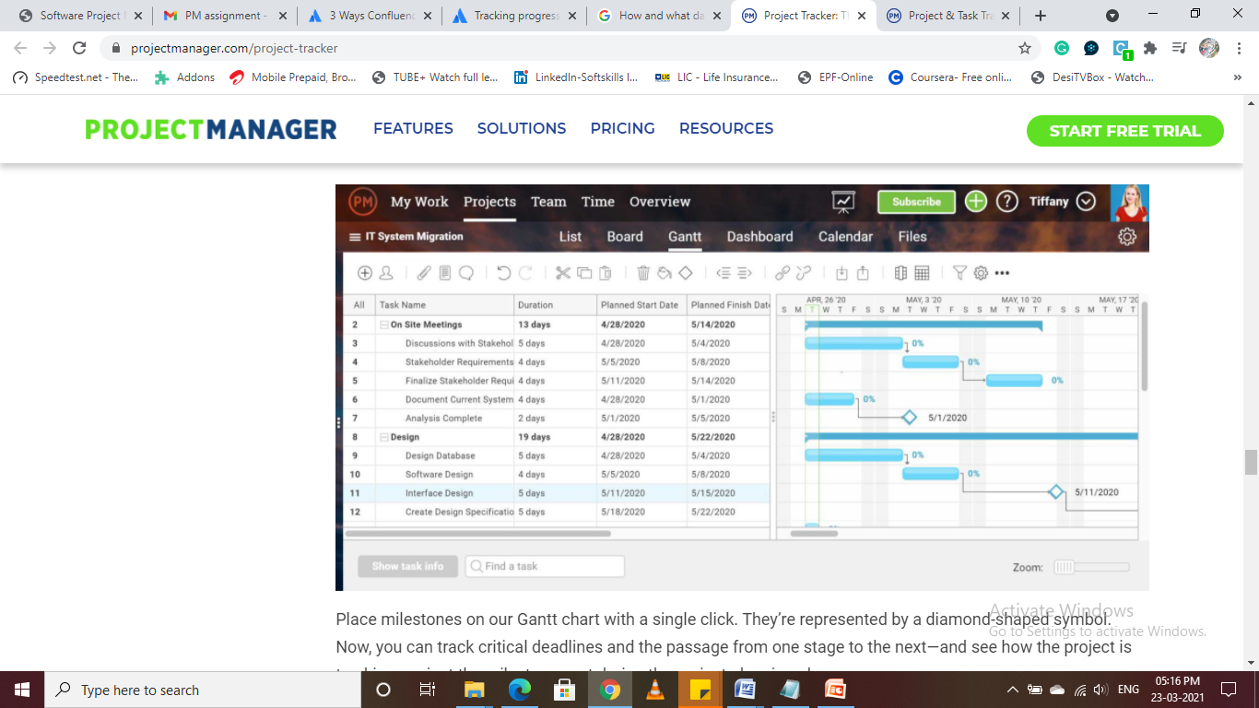

**Task 3.**

**If an individual is not delivering what would you do, what process would you follow how would you correct it?**

**Answer 3:**

Below are the ways where we can help underperforming individual / employee gain back their confidence and motivation for their job:

1. Taking action as soon as we notice underperformance :

One of the key components to help an underperforming employee is to act as soon as you start noticing underperformance signs

1. Meeting with employees to discuss their job performance:

Upon noticing changes in their work behaviour, schedule time for a one-on-one meeting. In the meeting, ask how they are doing with their current workload and address the areas of their job where they are underperforming

1. Establishing the cause of underperformance :

By establishing the cause of their underperformance, we can start to create a plan to help them succeed in the future and also a time frame where we expect their performance level to increase.

1. Having a discussion to establish long-term goals:

Sometimes employees forget what their long-term career goals are. This might cause them to underperform due to a lack of purpose. Asking them about their dream job and what inspired them to take the position they have now, could help them re-visualize their long-term goals and promote a better work ethic

1. Define their purpose within the company:

Discuss their contribution and the importance of their job duties. Explaining them the impact of notcompleting their job duties effectively and how they can maximize their efficiency.

1. Setting up regular meetings to discuss progress :

Setting up daily, weekly or monthly meetings to help monitor the progress of the employee

1. Providing continuous feedback :

Feedbacks are a powerful motivator. Provide them with constructive feedbacks on the areas of improvement and praising them when they have achieved their targets, could increase their confidence level and make them work even harder

1. Enrol employees in online courses or training :

If the employeemention a specific skill they want to improve that currently affects their job performance, assistthem to get enrol in an online course or training for that skill

1. Setting up with a mentor within Organization :
2. Reviewing job expectations and areas for improvement :

To promote productivity, remind the employee of job expectations for them and where they could improve

1. Encourage a healthy work-life balance :

Sometimes employees get so invested in their work that they end up working too much, causing them to feel strained or tired. This can cause them to lose their motivation to perform at the same level as before. We can prevent this by promoting a healthy work-life balance

1. Providing rewards for good work
2. Take a step back to encourage responsibility :

Once the employee begins to show improvements in their performance, allow them to retake responsibility in their daily work life while continuing to monitor their work. The goal is to eventually ease up on coaching as they progress.

**Task 4:**

**How would you maintain and be the gatekeeper for accurate documentation for each and every department on Confluence?**

**Answer 4:**

The Document Management System in Confluence with built-in features to manage, version, search and organize attachments for customers serves as an end-to-end replacement for a shared document repository.

Mounting Confluence as a **WebDAV** drive provides the ability to access documents stored in Confluence from the desktop. This allows to drag, drop, and open attachments from and within the native application on our desktop.

Additionally, Confluence provides direct integration with other document management systems: such as the SharePoint Connector for Confluence and a file connector for Confluence which allows integration with document management tools such as Box, Dropbox, and Google Drive.  Some additional apps like Comala Document Control and Scroll Documents

For Confluence provide workflow statuses to manage the document review process from draft to approval to release

**To keep track on documents and act as gatekeeper:**

#### Watch pages or the space

So that we know when changes are made, it's a good idea to “Watch pages” or even the entire space. That way, when changes are made to pages we arewatching or someone comments on them, we will get an email notification letting us know who changed what.

Whenever we are on a page in our documentation space, choose the Watch button at the top-right of the page. From there, we can choose to watch just that page, or all pages in the space.

#### View page history

Confluence creates a new version of the page every time someone edits the page. The [page history](https://confluence.atlassian.com/doc/page-history-and-page-comparison-views-139379.html) shows all the versions, with date, author, and any comments made on the update.

To view page history, we go to the page and choose https://confluence.atlassian.com/doc/files/704577869/704577870/2/1517274795952/ellipsis.png > Page History

On the page history view, we can:

* View the content of a specific version of the page.
* Revert to (restore) a specific version.
* Select any two versions and ask for a comparison, to see what has changed between those two versions.

#### Show a list of contributors

If we want to see at a glance who has updated a page or pages, you can add the “Contributors Micro”. This macro displays a customizable list of people who have contributed by creating, editing, or, optionally, commenting on the page.

**Task 5:**

**For new team members who join what process/documentation plan for their initial on boarding to maximise their productivity and integration in the team so they can ramp up as fast as possible.**

**Answer 5:**

The onboarding program should be planned in stages such as

* Prior to joining - by setting their expectations and comfort level to make sure they have a positive experience
* First day- making general announcement, conducting a tour, giving them schedule for week one, assigning a mentor etc
* First week- Walking through the important rules and procedures, introducing the company culture, providing setup guides, create a workbook with milestones, outline the training process and then start the training with weekly follow ups.

For the next 3 months, the focus should be on

1. establishing communication,
2. giving feedback,
3. setting mentor – mentee program,
4. Setting performance goals as well as giving performance review.

It is important to teach new hires the basic company policies.

Ensure that employees are aware of their responsibilities and how to fulfil their role correctly.

Making them aware of the culture of the organization by providing the formal and informal norms.

Encourage to connect and build relationships with colleagues and be a part of the team.

**(Please note:Below is a sample of detail Onboarding for New employee)**



**Task 6:**

**How would you handle internal communication amongst the teams to ensure all blockers are dealt with as fast as possible?**

**Answer 6:**

Below are few ways I would follow:

1. Using a work tracking tool like Asana or Trello to anticipate project blockerswhether teams work together or are scattered in different locations and time zones, communication issues can cause a lack of awareness of impeding problems. Customizable, easy-to-use work tracking software will project blockers from catching teams by surprise. These tools give our teams the opportunity to see each other’s progress and easily stay informed on any updates, issues, or blockers. Tracking can also give you a roadmap to follow back to the source of the blocker. We will be able to see which employees worked on the relevant tasks, when they worked on it, and what the actual problems are. Team members can also comment on any issues or delays they’re experiencing right in the task cards, which can facilitate early-warning communication about problems that are impeding their work.
2. Streamline the feedback cycle

Getting feedbacks from stakeholders can be tough. Often, projects rely on the feedback and approval of some of your organization’s busiest people. Many project blockers can be traced back to a feedback cycle that’s far from streamlined.

Improving our feedback cycle can mean removing people from the approval process, swapping them out for alternate stakeholders, or even just doing away with the approval process entirely. Not everything needs an executive’s stamp of approval

1. Automate as many tasks as we can

Automating Tasks and removing manual steps can make many processes flow much more smoothly. Automation speeds up workflows and eliminates potential bottlenecks and sticking points. It’s also more efficient, easier to monitor, and reduces the amount of time and money we have to spend on training.

1. Train to recognize project blockers

Avoidance and procrastination can delay the inevitable for a long time, but sooner or later, blockers have to be dealt with. Sometimes we have to acknowledge that we might need somebody else’s help to complete a task, or that we need to talk to a team member who’s holding up your progress.

1. Communicate about problems asynchronously

We don’t have wait for an immediate answer when we have a question about an issue that’s come up — using of asynchronous communication platforms , like those provided by work tracking tools, will allow shift of our focus to other tasks we need to work on until we get the require information .

1. Discuss project blockers in daily scrumDaily scrum is an ideal time and place to bring up blockers and brainstorm ways to neutralize them.

**Task 7:**

**What other ideas using previous experience or things you have seen work or not work would you implement to build a world class super productive team.**

**Answer 7:**

 The below model resembles a circle in which each component is linked with each other to show how each is equally vital in producing the desired solutions in achieving the best business results

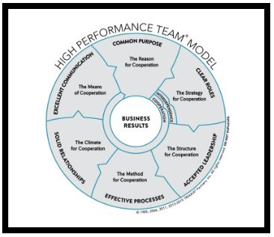

Following are few steps I will implement to build a world class super productive team:

1. Creating a Stable team :

Care and time should be invested to hand-pick a stable team, and once the team is formed, all care should be taken to maintain its stability. Apart from creating and developing a technically and functionally strong team, I believe an emotionally intelligent team is equally important. This can be done When we create a climate of trust and the sense that ‘We are better together than we are apart’.

Teams that enjoy high levels of group EI, have established norms that strengthen trust, group identity, and group efficacy. As a result, members cooperate more fully with one another and collaborate more creatively in furthering the team’s work.

This can be done by small efforts like:

* Make time for team members to appreciate each other’s skills
* Surface and manage emotional issues that can help or hinder the team’s progress
* Celebrate success

1. Building a Cohesive and Value Aligned Team Dynamics :

It is vital to create a team where each member shares a bond and interacts freely. This happens when they align with our leader's values and work in unison to achieve a common goal. When team members start believing that they can win together, they get more done. Shared values, high-level of interaction, and a sense of trust among members — aspects that constitute a cohesive team, increase productivity in great measure.

1. Encouraging an Environment of Open Communication:

I will take care to build a working environment that fosters interpersonal risk-taking. This kind of team culture will motivate employees, encourage innovation, and help take new ideas to implementation levels.

1. Stress on the Importance of Continuous Learning

I will foster a culture of continuous learning to navigate the issues of skill gaps and different digital transformations essential to build a high-performance team. Although a significant amount of learning takes place between team members, upgrading a team's ability through documentation tools and training is equally essential in building a high-performance team